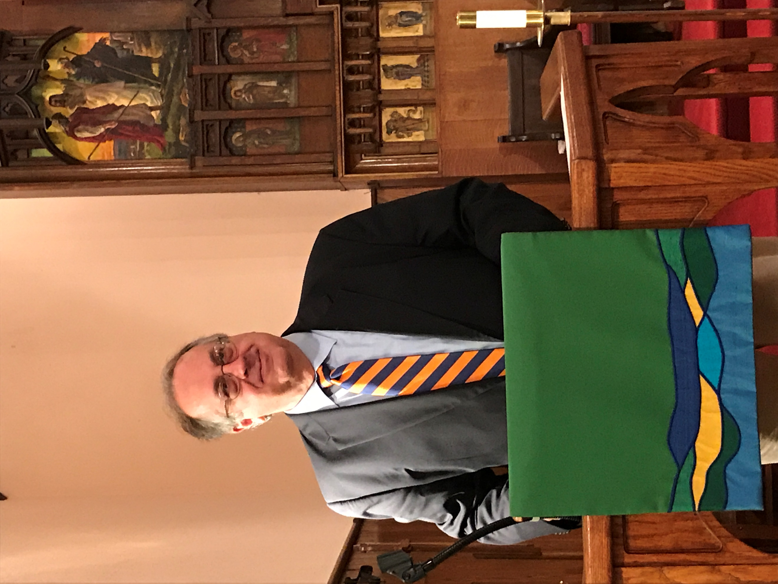
Stewardship Sunday – October 27, 2019

You are the light of the world. A city set on a hill cannot be hidden. Nor do people light a lamp and put it under a basket, but on a stand, and it gives light to all in the house. In the same way, let your light shine before others, so that they may see your good works and give glory to your Father who is in heaven.

This was a reading from the Gospel according to Matthew.

I’ve known Paul Bartkus, our Senior Warden, for a long time now. I worked with him as a Junior Warden some 15 years ago. I’ve worked with him on the Capital Campaign that funded Snyder Hall. I’ve worked with him on Maintenance Mornings, annual meetings, and vestry retreats. He is a faithful parishioner who has done so much to keep St James’ successful.

I’ve also learned to be wary of him. If you let your guard down, he will ask you to volunteer for something that you really don’t want to do. You can say no, but somehow you always get to yes. Ask me how I know this.

So, I was minding my business one day last summer when Paul sauntered over to chat. He lulled me with a funny story or two, and then sprung his trap. “How would you like to speak on Stewardship Sunday?” In my mind, I was shaking my head: “NO THANK YOU.”

Paul gave me the puppy dog eyes before I had a chance to say a word. I felt my resistance ebbing away, and found myself croaking: ” YES, I’D LOVE TO, PAUL.”

He’s good.

I love this place. I love the history, the sanctuary, the bell tower, the parish hall, Mitcham House. I love the worship, the liturgy, the truth that is spoken here. Most of all, I love the community of St James’. What a great thing – people working and worshiping together with love and devotion. We make a difference. You light me up, inspire me, and keep me humble and grounded.

Each of us is called to make sure we are letting God’s light shine through our work, our friendships, our service, and our giving. As a faith community, St James must shine the light of Christ through our worship, welcoming, pastoral care, and outreach. How we use our time, talents, and treasure determines how brightly we are shining our light.

I’d like to invite you to shine your light just a little brighter.

Today, I’m focused on treasure. St James’ needs your financial pledge to continue our mission. I realize that some of us are uncomfortable with pledging, but please consider two things. First – our pledges give St James’ a predictable financial base for planning and programs. Second – a commitment to the church helps deepen your relationship to the church. If circumstances change, you can change your pledge at any time.

I am asking you to pledge. If you pledge already, I’m asking you to increase your pledge by ONE DOLLAR A WEEK. Every dollar helps. Together, we can accomplish a lot.

I like to look around our church and remember how we got here – an (almost) unbroken line of parishioners dedicated to its stewardship.

In 1859, our country was entering the darkest period in its history. St James’ Episcopal Church was organized and built – and it didn’t come easy. According to a news account of the time, during construction the entire framework was demolished by a tornado, and had to be rebuilt at the cost of hundreds of dollars.

Attendance dropped over the years, money got tight, and St. James’ closed its doors in the 1890s. The church was sold and became a theater. By 1901, Teddy Roosevelt was President, and we entered the Electrical Age. The people of St James’, led by Father Mitcham, reorganized and reestablished the church, buying this building back from the theater. Soon thereafter, the rectory was built, which many years later was christened the Mitcham House in his honor. We still have a reminder here of the theatre period. Our choir loft was built to provide more seating for their shows, and it still serves us well.

By the 1990s, we began planning for the 21st century. After much discussion, we decided to stay in Hackettstown. We came together to renew the sanctuary, and build a new parish hall. We celebrated our 150th anniversary in 2009. We’ve come a long way.

The church leadership has done great work in managing our finances. Our parish hall mortgage is well on the way to being paid off. Capital projects are responsibly managed. Our day-to-day expenses and income are reviewed at every vestry meeting. I can tell you that it costs a LOT to run St James’, yet every line item is scrutinized and scrubbed. Inreach and outreach don’t come cheap. We are OK, but we could do more if we had more. That’s where your light comes in.

What DO we do with the money? First and foremost, we have a priest again after a very long road. I’m so glad to have Father Wayne on board with us. We have a small and dedicated staff that keeps our house in order. Our operating budget covers the barest of essentials - salaries, administrative costs, utilities, maintenance, outreach, and more.

A recent vestry meeting is instructive. We were filling out a diocesan application form, in which we were asked to describe our outreach. We all looked at each other and struggled with this. Then we started to get some traction and the light started pouring out – backpack program, North Porch, Christmas charity, Thanksgiving turkeys, winter coats for kids, Colonial Manor - the list went on. Then there is the inreach – the worship, coffee hours, fellowship dinners, friendship, and community that we share. All of this is made possible by your generosity.

The vestry has completed its pledge for 2020 – I’d like to invite you to do the same. Each one of us is called to make sure we are letting God’s light shine through our work, our friendships, our service and our giving. We are called to be light bearers. It is a powerful calling.

Please consider making a pledge to St James’ for 2020. If you already pledge, consider increasing it by one dollar a week. If you can give more, all the better, but I hope you can all join us in increasing your pledge by just a dollar. There is always more to do, and your pledge makes it possible.

I hope you will join me as we work together to shine our light in our church, our community, and in our lives. I’m grateful that we are part of the St. James’ family.
David Olesen

